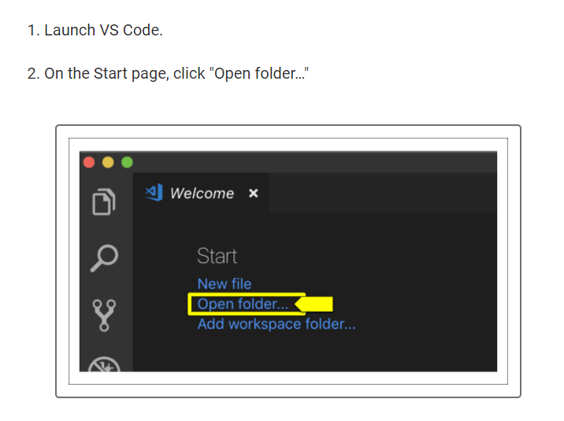

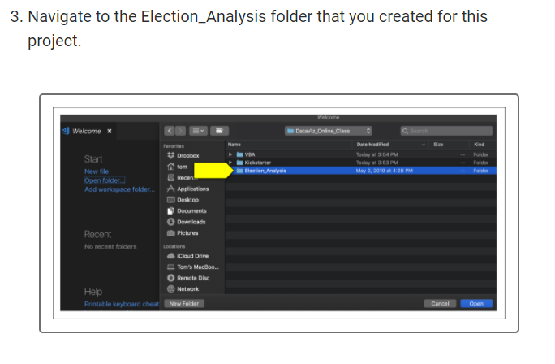

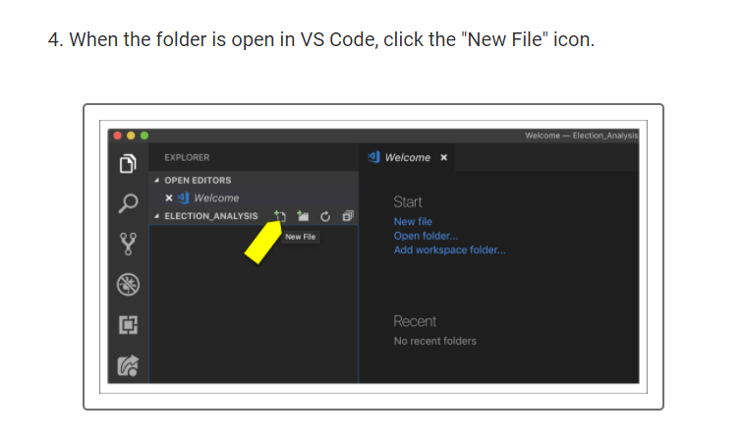

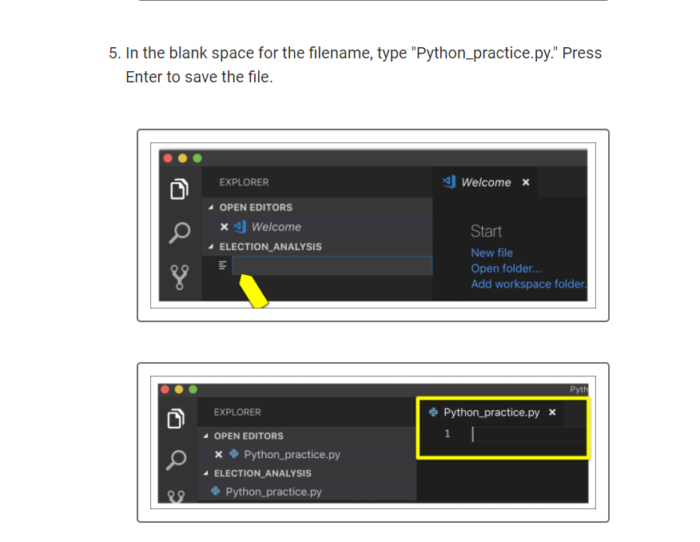

**IMPORTANT**

If you do not add the .py extension to the Python file, you will not be able to run the file.

**Windows**

Use the following instructions to learn how to run a Python file in VS Code as well as in the Python Command Prompt.

**Run a Python File in VS Code**

In Python_practice.py in VS Code, type print("Hello World"). Your Python file should look like this:

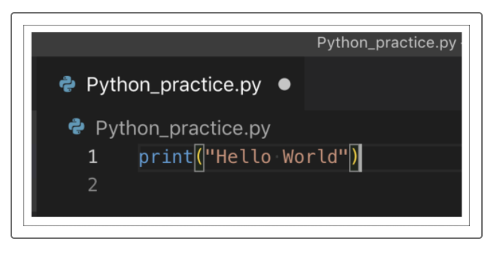

The white dot next to the filename indicates that the file has been edited but has not been saved. If we want to execute this file, we need to save it. Save the file using the keyboard shortcut CTRL+S or you by selecting "Save" from the File menu.

To run the Python file, we can click on the filename in the Explorer and select "Run Python File in Terminal."

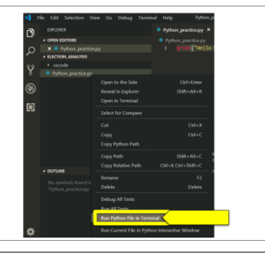

We can also click anywhere in Python_practice.py and select "Run Python File in Terminal."

